Energy Champions -- Sep 13, 2021
By Alex Epstein

This document contains new messaging for the September 13, 2021 Energy Champions meeting.

I'll be giving two presentations: "How to use the new EnergyTalkingPoints.com" and "Resourceful Researchers"
General Messaging and Strategies
Opposing the horrific, Unconstitutional Clean Electricity Payment Program
The CES has morphed into the Clean Electricity Payment Program. Here are my updated talking points.
In one of the most dangerous and most Unconstitutional acts in US history, Congress and the President are abusing the budget reconciliation process to dictate, via a “Clean Electricity Payment Program,” that Americans use >50% unreliable solar+wind electricity by 2030.
- Thanks to government mandates and subsidies, solar and wind--"unreliables"--provide about 10% of American electricity. This 10% has already caused big electricity price increases and huge reliability problems. Politicians should admit their failure, apologize, and reverse course.
- Instead of admitting that the US's 10% solar+wind electricity is causing huge cost and reliability problems, our government, led by the Senate, is quintupling down on this disaster by pushing a "Clean Electricity Payment Program" that would require >50% solar+wind in 8 years!!
- The CEPP would mandate 80% "clean electricity” by 2030--but does nothing substantial to reverse the criminalization and defunding of nuclear. So nuclear will decrease from its 20% share today. Hydro, at <7% today, has little room for growth. That means >50% solar/wind!
- Unreliable wind and solar cannot replace fossil fuels. Because they can always go near zero--as we saw recently in Texas--they don't replace the cost of reliable power plants, they add to the cost of reliable power plants. That's why more wind and solar = higher prices.
- Consider: Germans, to get 37% of their electricity from wind/solar, have doubled their prices--now 3X US prices. And they can only get away with 37% because they have neighbors to bail them out when solar/wind fall short. The US as a whole has no such neighbors.
- In California, where I live, we get 24% of our electricity from wind and solar--and we have skyrocketing prices along with disastrous shortages and blackouts. And it would be far worse if we couldn't import 30% of our electricity from neighbors.
- Contrary to media denial, government favoritism for solar and especially for wind were absolutely to blame for the Texas blackouts. TX defunded reliable power plant construction as well as resiliency measures (like weatherization) to pay for solar/wind.
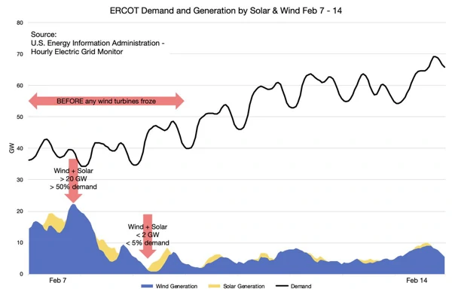
- During TX's February cold spell, wind and solar disappeared when they were needed the most. Its expensive batteries, which could store a mere 40 seconds, didn’t help, either. What would they have done under the CEPP's 50% solar and wind??!!
- The facts are clear. 10% solar and wind in the US is disastrous. 50+% solar and wind would guarantee unaffordable prices, constant shortages, frequent blackouts--and the fleeing of industry and jobs, once companies realized the US no longer had low-cost, reliable electricity.
- Historically, the Constitution protected us from terrible ideas like the CEPP--which would more accurately stand for Catastrophically Expensive Power Program. It was recognized that the Federal Government cannot dictate the electricity choices of all Americans.
- Ominously, today the Constitution is so ignored that government and media consider it totally okay to grant the Federal Government dictatorial control over all electricity *as part of a budget reconciliation process*. What country are we living in?
- The budget reconciliation process is supposed to be about budgeting, not about giving government new powers. Yet shameless Senator Chuck Schumer has bragged that the CEPP and other "reconciliation" measures would constitute "the most significant climate action in our country's history."
- Our government's push for mandating 50+% unreliable solar and wind plays perfectly into the hands of China. China has a clear strategy of running its economy on 84% fossil fuels, while encouraging us to run on unreliable solar and wind—that is made using Chinese fossil fuels.
- The claim that a "Clean Electricity Payment Program" will lower global CO2 emissions is a joke. As China illustrates, the world, especially the developing world, will overwhelmingly use fossil fuels because that is by far the lowest-cost way for them to get reliable energy.
- Anyone who cares about CO2 emissions must recognize that the only non-carbon energy source that has a chance of outcompeting fossil fuels and lowering global emissions is nuclear energy. Nuclear is incredibly safe, incredibly reliable, and can be generated anywhere in the world.
- Unfortunately, nuclear has become ultra-expensive in the US because politicians (mostly Dems) have demonized it and virtually criminalized it through endless unscientific regulations--along with wind/solar favors+subsidies, like the "PTC," that defund reliable nuclear plants.
- US policy is so anti-nuclear that virtually no one will attempt to build a nuclear plant in this country--and in 2021 utilities are planning to shut down a record amount of our existing low-carbon, low-cost, reliable nuclear power plants!
https://www.eia.gov/todayinenergy/detail.php?id=46436
- Any policy serious about CO2 emissions needs to recognize the severe deficiencies of wind/solar and *make nuclear decriminalization priorities number 1, 2, and 3*. Instead, our government wants to dictate catastrophic amounts of wind and solar using the "CEPP."
- The proper path forward for America is to fix our broken electricity system by ending all mandates and subsidies for unreliable solar and wind, liberating nuclear energy, and making sure to have enough low-cost, reliable power plants to handle every situation.
- When we look at the decline of nations throughout history we wonder: How could they not have seen it coming? Today, we should clearly see it coming that a CEPP, destroying our grid with catastrophic amounts of unreliable solar+wind, produced by China, will mean our decline.
- Please tell your Senators and other elected officials--above all Senator Joe Manchin and Senator Kyrsten Sinema--to publicly denounce the deadly and Unconstitutional Clean Electricity Payment Program, and refuse to participate in any budget reconciliation process that involves it.
The dangerous falsehood that "Climate change is a public health issue"
"Climate change is a public health issue" is a dangerous new refrain that is being used to justify some truly evil policies--including a government mandate to restrict hospitals' electricity use if the CO2 emissions are deemed to be too high! Here are two sets of points about "climate change is a public health issue."
The Biden Administration's Department of Health and Human Services has launched an office that will "treat climate change as a public health issue"--including by compelling hospitals to emit less CO2. If this office is not stopped it will absolutely kill people.
- ​​The Wall Street Journal Reports that The Office of Climate Change and Health Equity "could eventually compel hospitals and other care facilities to reduce carbon emissions." Forced emissions reductions always make energy more expensive or less reliable.
https://energytalkingpoints.com/energy-q-a/
- Hospitals have huge energy costs--often 50% of their budgets--and they depend on ultra-reliable energy. Is the Administration going to raise their prices so they use less energy? Is this Administration going to force respirators and incubators to run on unreliable solar and wind?
- As the Wall Street Journal reported, during the pandemic "many hospitals have had to run air-purification systems at a higher level, resulting in increased energy use and more carbon emissions." Would the Biden Administration have forbidden that, killing people to reduce CO2?
- The idea that restricting CO2 emissions at hospitals is going to help poor people by protecting them from climate change is absurd. The number one health risk is poverty. Nothing matters more to the poorest Americans than economic opportunity.
- The Biden Administration's support of a "Clean Energy Standard" is a guaranteed prescription for mass poverty, that would harm everyone's health, especially that of the poorest Americans.
https://twitter.com/AlexEpstein/status/1418243194727194626?s=20
- We know that lower incomes are associated with worse health outcomes since income impacts things like our ability to afford healthy food, preventative health care, quality health insurance, and costly medical treatments.
- Poor adults report being in fair or poor health five times as often adults in families making more than $100,000. And lower incomes translate into significantly lower expected lifespans.
- The less wealthy you are, the less healthy you are: even Americans in the top 10 percent of incomes have worse health outcomes on average than Americans in the top 1% of incomes. Any policy that harms prosperity harms health.
- Human beings are impacting the climate, but there is no climate crisis. In fact, using low-cost, reliable energy from fossil fuels we have made ourselves far safer from climate than ever.
- https://energytalkingpoints.com/climate-crisis/
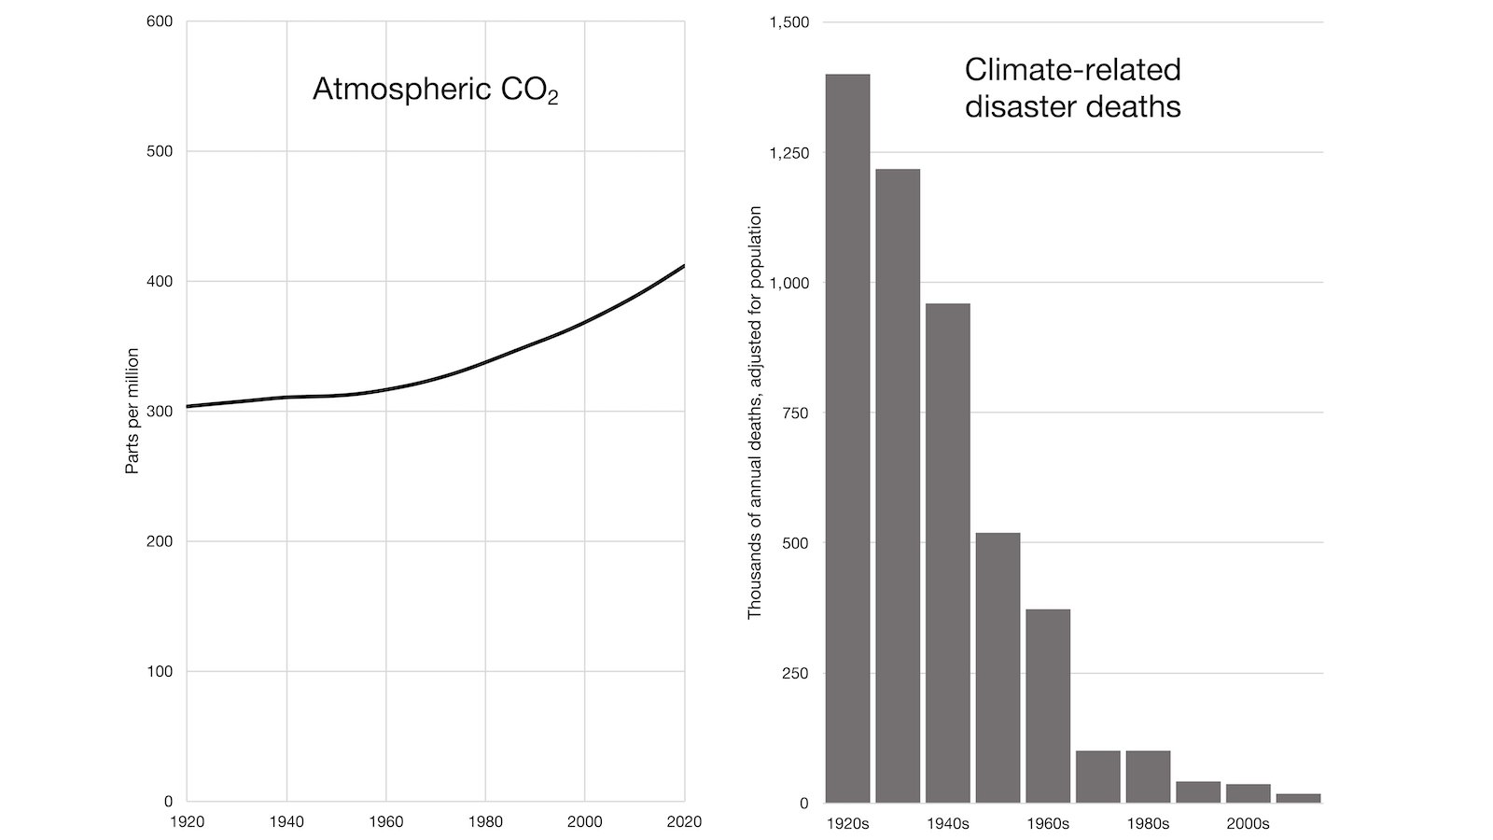
- If the Biden Administration actually cared about CO2 emissions, it would liberate nuclear energy, the best hope for low-cost, reliable, global-scale non-carbon energy. But instead of liberating nuclear, it is trying to deprive our hospitals of energy.
https://energytalkingpoints.com/co2-emissions/
- The whole idea that "climate change is a public health issue" is a fraud. Climate change involves slow global warming, concentrated in colder regions, in a world where cold-related deaths far exceed heat-related deaths.
https://financialpost.com/opinion/bjorn-lomborg-climate-change-and-deaths-from-extreme-heat-and-cold
- The real "public health issue" is this Administration's irrational *climate change policies* that, by making energy more expensive and less reliable, promote health-destroying poverty and deprive us of the affordable heating and AC we need to be safe from dangerous temperatures.
- I am in Austin today and it's 92°. If not for 170 years of fossil fuels maybe it would be 90°.
Would any climate catastrophist trade 92° with AC for 90° with no AC--and without the abundant food, clothing, shelter, medical care, and free time fossil fuels make possible?
Today is a dark day for the medical profession. The editors of 220 medical journals, with 0 expertise in energy and climate, have called for the rapid elimination of fossil fuel use--a course of action that would rapidly increase the biggest cause of health problems: poverty.
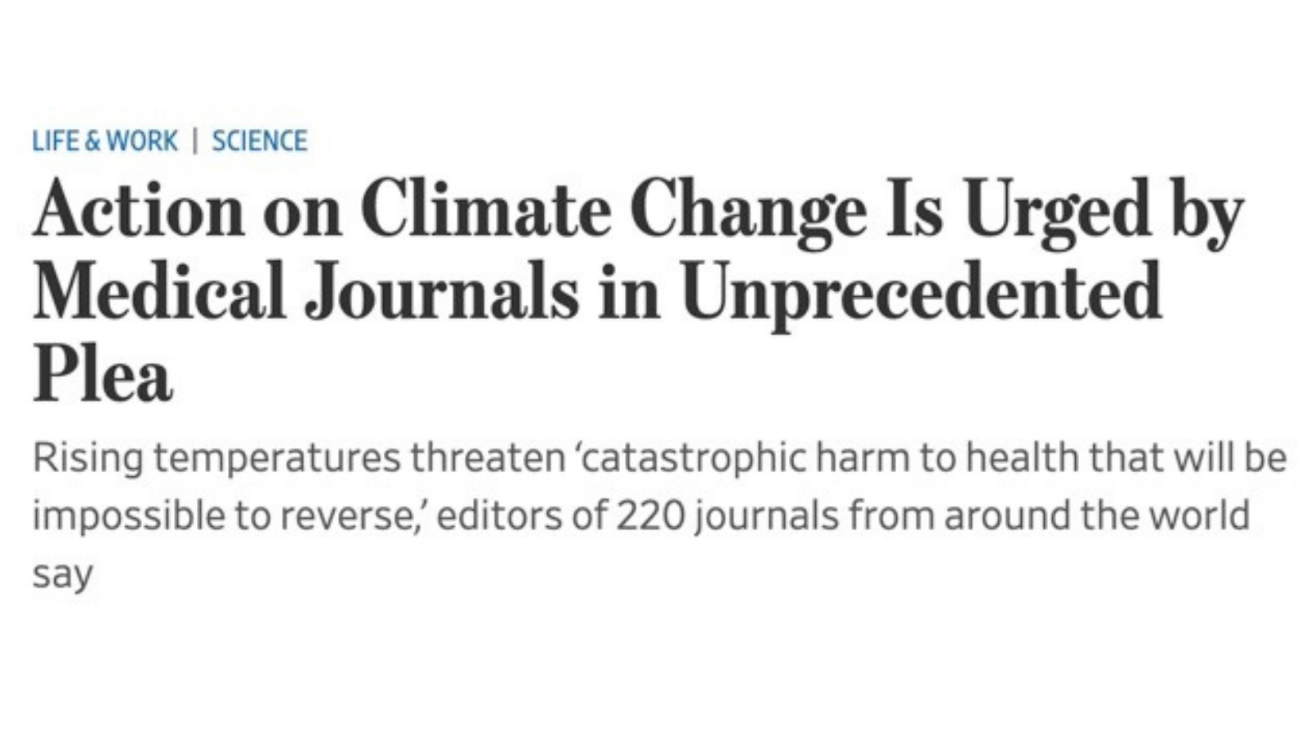
- The #1 cause of health problems in the world is poverty, and an absolute requirement for alleviating poverty is low-cost, reliable energy—most of which, for the foreseeable future, needs to come from fossil fuels.
- The main reason global CO2 emissions are rising is because billions of people in the developing world are bringing themselves out of poverty by using fossil fuels to power factories, farms, vehicles, appliances--as well as hospitals and medical equipment.
https://energytalkingpoints.com/co2-emissions/
- The developing world overwhelmingly uses fossil fuels because that is by far the lowest-cost way for them to get reliable energy. Unreliable solar and wind can’t come close. That’s why China and India have hundreds of new coal plants under construction.
https://energytalkingpoints.com/co2-emissions/
- We know that lower incomes are associated with worse health outcomes since income impacts things like our ability to afford healthy food, preventative health care, quality health insurance, and costly medical treatments.
- It is appalling that 220 medical journals are calling for rapid, poverty-increasing, health-destroying reductions in fossil fuel use in the name of climate change—whose main health risk, heat-related death, is a far smaller problem than cold-related death.
https://financialpost.com/opinion/bjorn-lomborg-climate-change-and-deaths-from-extreme-heat-and-cold
- Human beings are impacting climate, but there is no climate crisis. In fact, using low-cost, reliable energy from fossil fuels we have made ourselves far safer from climate than ever--and we have made every aspect of our lives better.
https://energytalkingpoints.com/climate-crisis/
- Please write to any medical journal that published the deadly editorial--such as The Lancet and The New England Journal of Medicine --and tell them to retract and apologize for it. They are helping advance fossil fuel elimination policies that will shorten billions of lives.
New graphs on declining climate danger from Fossil Future

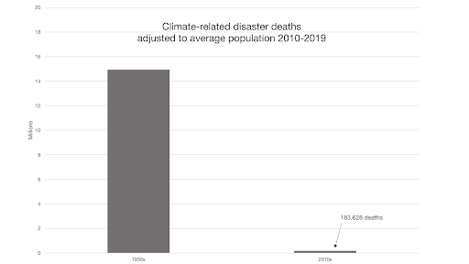
How media covers climate
This is how media covers climate:
Among the thousands of places around the world, pick the ones with the worst weather right now. Among them, pick the ones where the weather hasn't been this bad for awhile. Blame "climate change." Propose totalitarian control over energy as the solution.

The truth about Ida in Louisiana
Hurricane Ida proves once again that human beings' climate mastery ability matters far more than our climate impact.
Check out this great thread from Michael Shellenberger: https://twitter.com/ShellenbergerMD/status/1432510101261193217
The truth about flooding in New York
100% true from a thread by Michael Shellenberger: "The reason New York is flooded is because of bad infrastructure not a few more inches of rain" And infrastructure is within our direct, immediate control while rainfall isn't.
Charlatans ignore infrastructure, demand power to change rainfall.
Read the whole thing: https://twitter.com/ShellenbergerMD/status/1433424444295303169
Here's some more good info from Roger Pielke, Jr.: https://twitter.com/RogerPielkeJr/status/1349012983255601154
The false claim that disasters are 5 time more common
Read this whole thread by Bjorn Lomborg exposing yet another form of climate distortion: using the fact that we have more comprehensive reporting of climate disasters than we used to--to claim that climate disaster frequency has dramatically increased.
- https://twitter.com/BjornLomborg/status/1433049198165962763
Translating "[Bad thing] was caused by climate change" and "1.5 degrees"
Here are two points that will help you know the truth in the fact of media climate distortions.
- Anytime you hear "[Bad thing] was caused by climate change," translate it to "[Bad thing] was caused by 1°C warming in the last 170 years."
This will make it obvious that at least 90% of these claims are BS.
- When people talk about 1.5°C of warming as catastrophic, it's even more absurd than it sounds because it's not 1.5°C warming starting now, it's 1.5°C total since the 1800s. Which means 0.5°C warmer than now--in a world where far more people die of cold than of heat.
The growing recognition of the need for better forest management
- Finally, a politician proposes actually doing something about dangerous wildfires by addressing the root of the problem, bad forest management. Check out this new bill by Rep. Lauren Boebert. This is definitely the direction we need to be heading.
https://boebert.house.gov/media/press-releases/rep-boebert-introduces-comprehensive-bill-prevent-catastrophic-wildfires
- "The fire here is burning at a lower intensity because the fuels have been managed"
-- Gavin Newsom's office.
If only Newsom had focused on forest/fuel management for the last several years instead of destroying reliable electricity then mandating EVs...
https://twitter.com/CAgovernor/status/1430344420637872134?s=20
- People who want to *solve* the problem of dangerous wildfires support forest mastery practices like this. People who want to *use* the problem of dangerous wildfires to gain status and power blame climate change and do nothing.
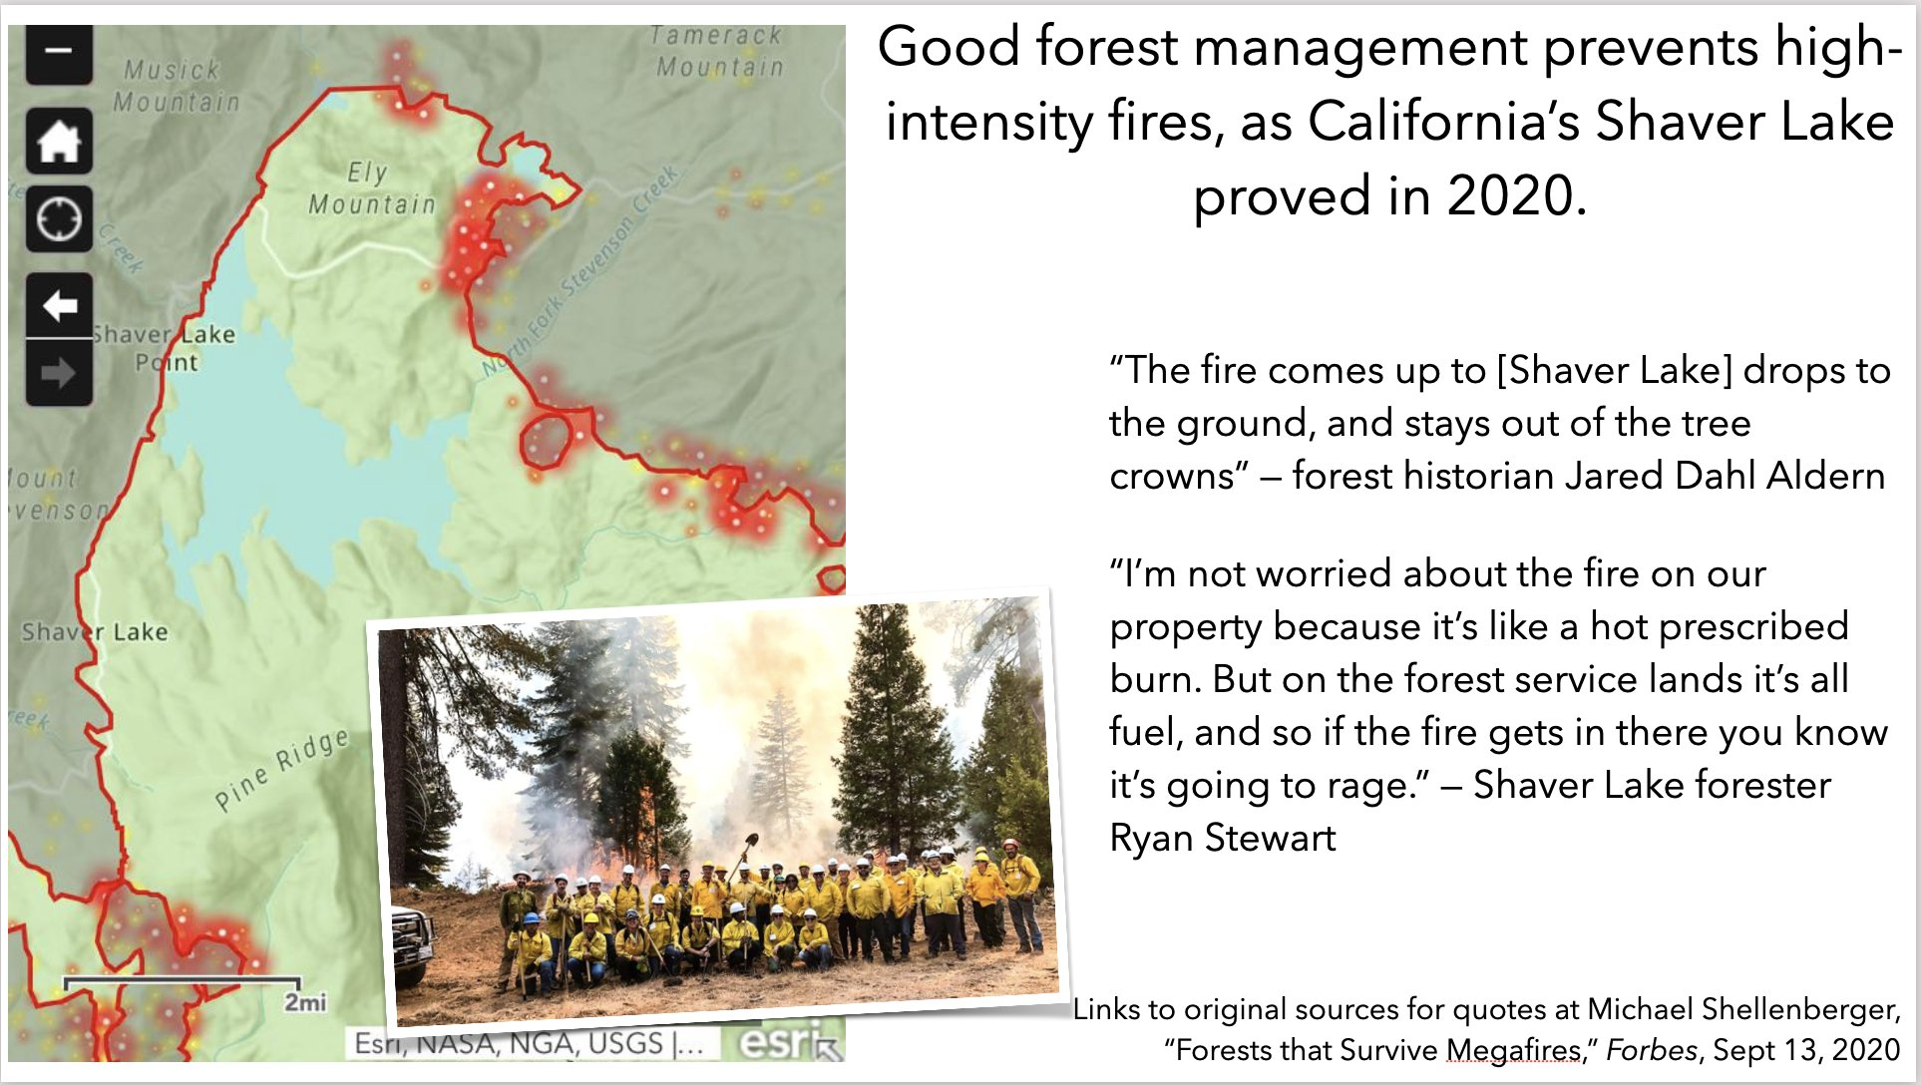
Documenting the failure of green energy around the world
One of the most powerful counters we have to "plans" involving a lot more solar and wind is to show the terrible reality such plans have already created.
- Cautionary tale: Australian Senator Matthew Canavan said the functioning of Australia’s power system has been 'completely destroyed' by the surge in renewables investment over recent times. 'And now, guess what, we’ve got to subsidise the reliable power'"
- This data from Ontario shows the same thing we saw in the disastrous Texas blackouts earlier this year: wind "power" is available the least when you need power the most.
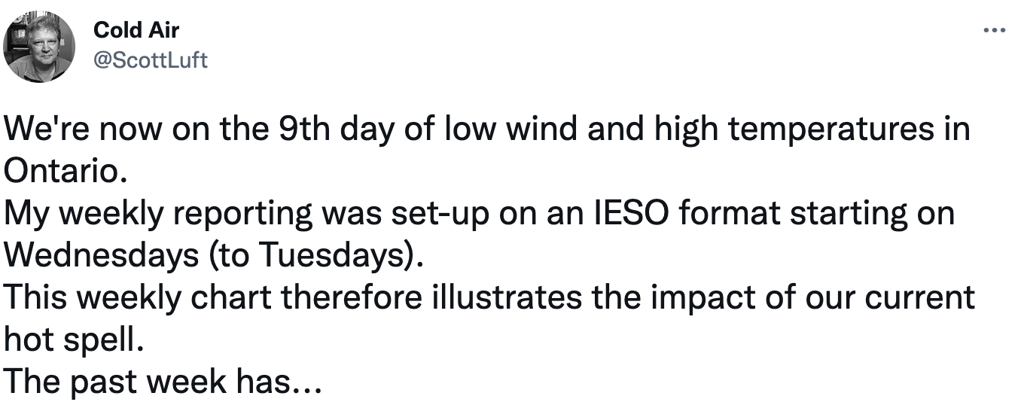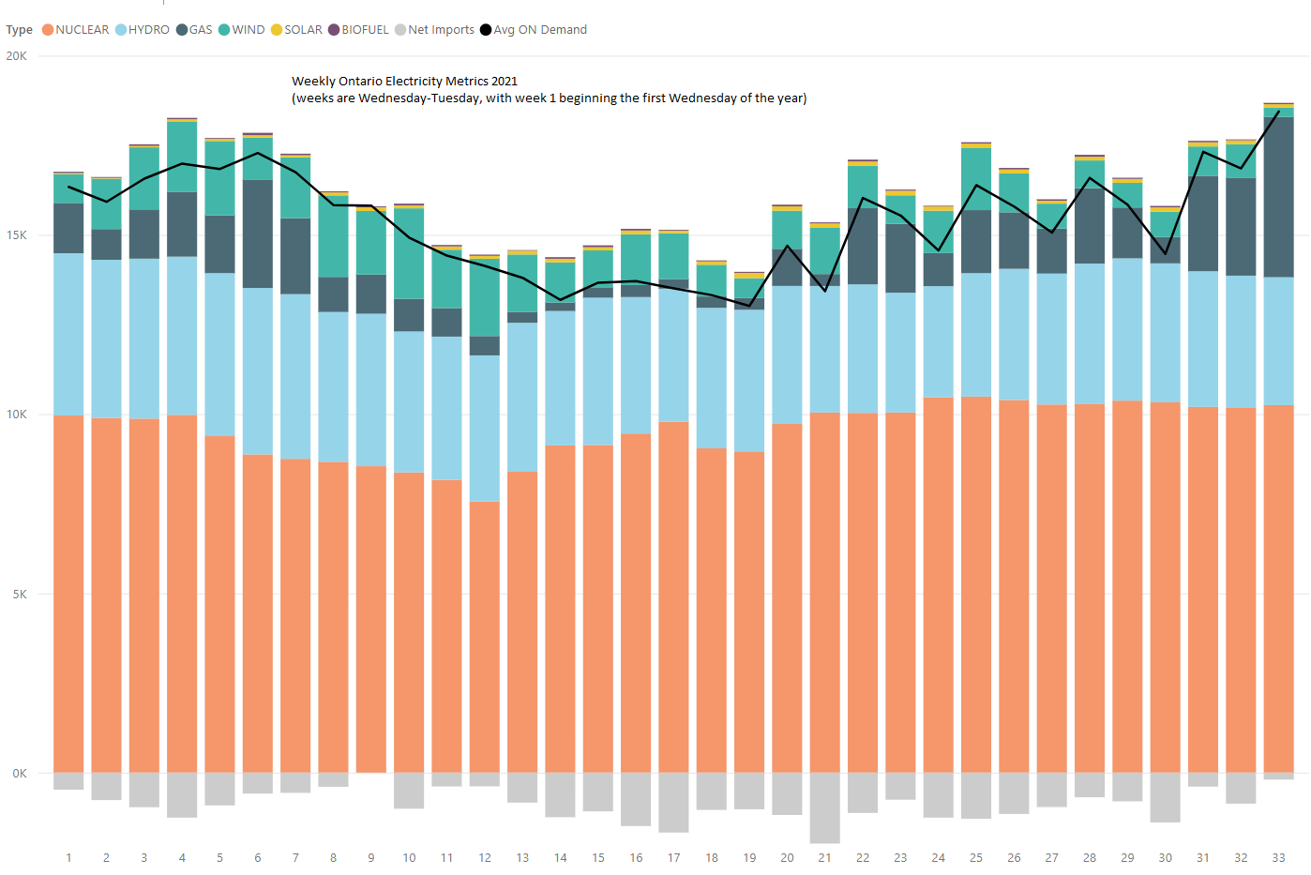
- When Gavin Newsom really needs electricity to work, he turns to the same solution that so many of our oil-condemning tech companies do: diesel.
Michael Shellenberger: To avoid blackouts for 2.5M Californians, Gov. ⁦Gavin Newsom⁩ issues emergency declaration allowing for burning of diesel, even as he moves forward with his plan to shut down Diablo Canyon nuclear plant, which provides power for 3M
https://www.reuters.com/business/energy/californias-clean-grid-may-lean-oil-gas-avoid-summer-blackouts-2021-08-11/

- Germany is having disastrous problems with 37% solar + wind and neighbors to bail it out when sunshine and wind are inadequate. So why are we in the US, who lack such neighbors, talking about a "Clean Energy Standard" that would mandate >50% solar + wind?
https://twitter.com/ShellenbergerMD/status/1429795993256566786?s=20
- Coal keeps the lights on, not just in Kentucky and West Virginia, but also in Los Angeles.
Share this with your favorite anti-fossil fuel celebrity so they know what's powering their Tesla.
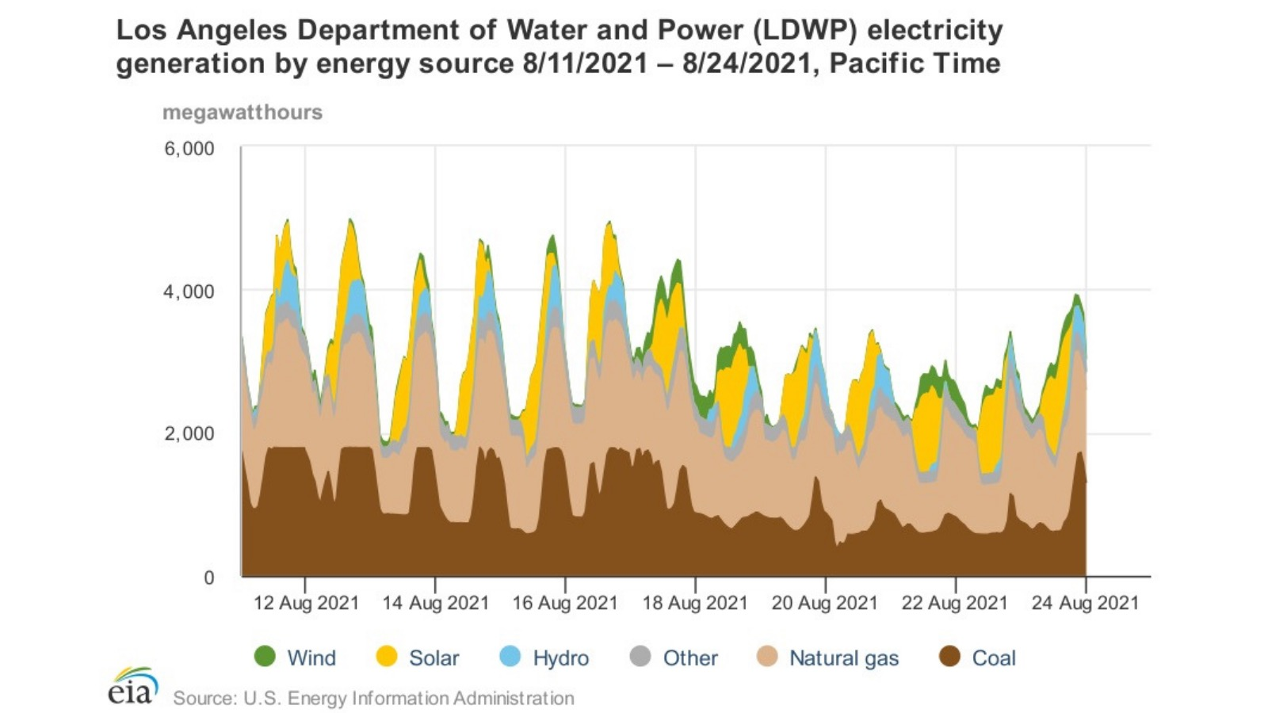
It's also valuable to use the failure of green energy when people tell fake "success stories" about it--e.g., my response to Paul Krugman
- Economist Paul Krugman asks, “Who Created the Renewable-Energy Miracle?”
The answer: His delusion.
Observe what happens to electricity prices when significant solar and wind is added, like in Germany (37%) and California (24%). This is not a miracle, it’s a mess.
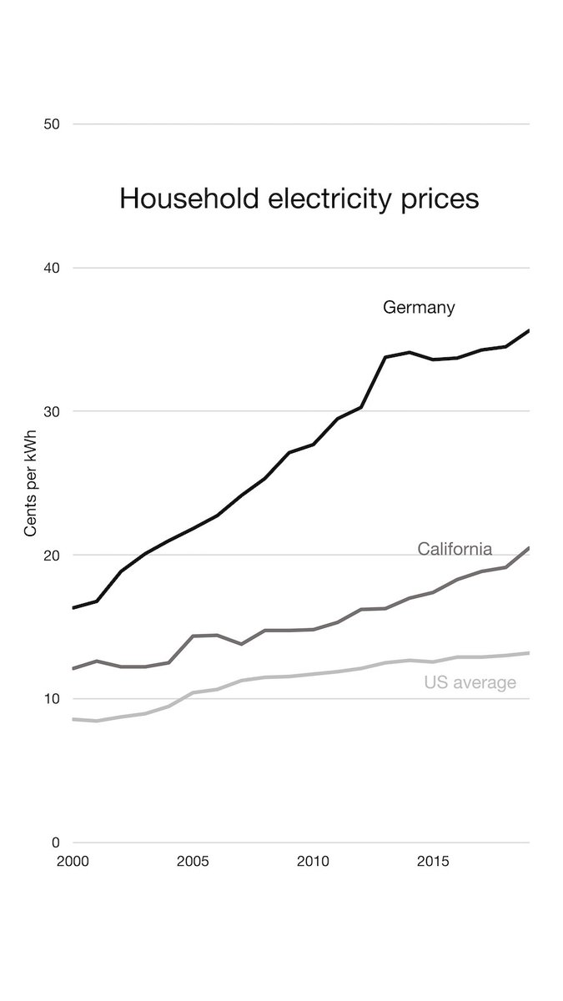
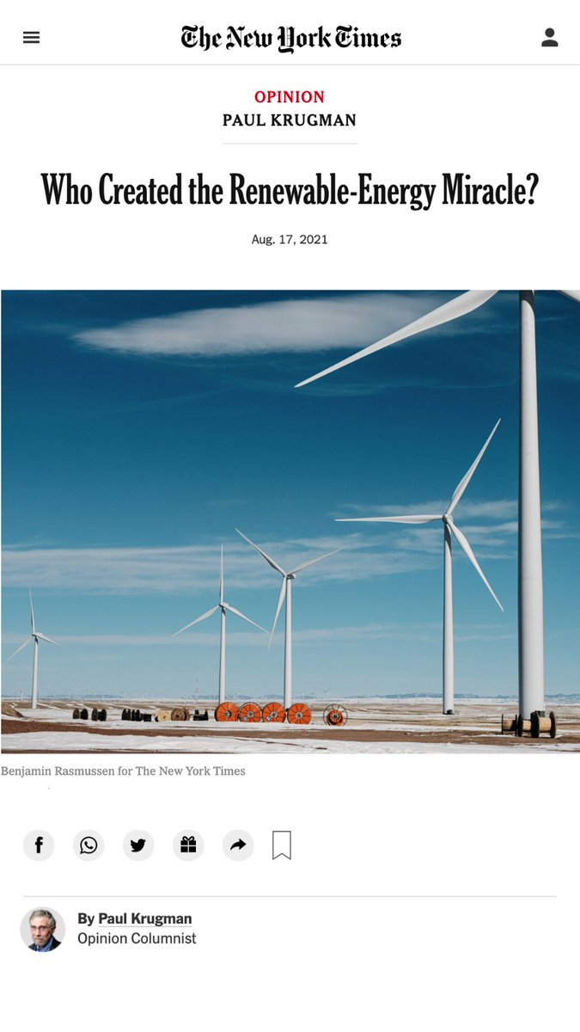
Good climate-related news that's not being covered
Last meeting I discussed the need to neither "deny" climate impact nor to treat it as all negative. Here are some recent new points about good climate-related news that gives a fuller picture of our impact on climate.
- "Romania reaps record 11.4 mln tonnes wheat crop"
The story makes no mention of CO2 or climate--though both are surely relevant. As usual, good conditions are assumed to be caused by nature, bad conditions are assumed to be caused by humans.
https://www.nasdaq.com/articles/romania-reaps-record-11.4-mln-tonnes-wheat-crop-2021-08-25
- If we had real newspapers, this story Vijay Jayaraj reports about record agriculture in India, made possible by fossil fuels, would be global news.
https://www.westernjournal.com/climate-alarmists-ignoring-time-record-crop-production-india/
- I would be much more inclined to believe stories that a given bad weather event was “caused by climate change” if there were even 10% as many stories about good weather events “caused by climate change.”
The reason we don't hear about good weather events "caused by climate change" is anti-human bias.
https://twitter.com/AlexEpstein/status/1421560513255804929?s=20
- Here’s economist Ross McKitrick on why there are so few stories about good weather events caused by rising CO2 levels.
“Because they never look for them. They’ve never done a study on whether a stretch of pleasant weather would have been a devastating storm if not for climate change. They only look at bad events. That’s why the fact that they only find bad events is meaningless.”
https://twitter.com/RossMcKitrick/status/1430347669499678728
- Dear CBS News, This study of Afghanistan's agriculture concludes "The predicted impact of future climate change is largely beneficial, mainly due to warming."
Will you soon be publishing a story on "How climate change helped weaken the Taliban"?
https://sciencedirect.com/science/article/abs/pii/S104900782030021

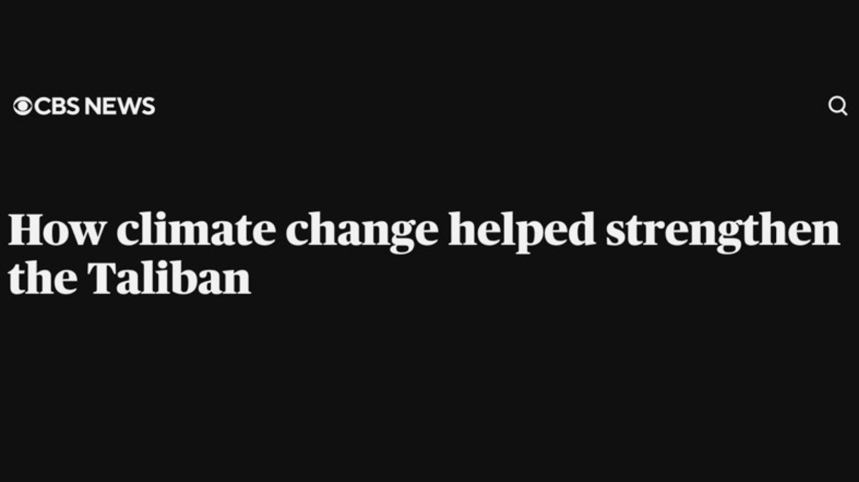

The California election
I've been tweeting a bunch about the need to remove Gavin Newsom from office--and why I support Larry Elder as the replacement.
- Here's how GavinNewsom has contributed to out-of-control wildfires and resulting air quality problems. Larry Elder has embraced rational forest management.
https://energytalkingpoints.com/california-wildfires/
- Here's how Gavin Newsom has contributed to blackouts. Larry Elder has embraced, low-cost, reliable electricity.
https://energytalkingpoints.com/california-blackouts/
- Gavin Newsom "fought Covid" by making it illegal to go to the beach even though we should be been going outdoors a lot more. (Here's me violating his dictates to enjoy bioluminescent night surfing.) Larry Elder has rejected rights-violating lockdowns.
https://twitter.com/AlexEpstein/status/1430571939358154760?s=20
- "The fire here is burning at a lower intensity because the fuels have been managed"
-- Gavin Newsom's office.
If only Newsom had focused on forest/fuel management for the last several years instead of destroying reliable electricity then mandating EVs...
https://twitter.com/CAgovernor/status/1430344420637872134?s=20
- When Gavin Newsom really needs electricity to work, he turns to the same solution that so many of our oil-condemning tech companies do: diesel.
- https://twitter.com/ShellenbergerMD/status/1429456565715623944?s=20
- A NYT hit piece by Farhad Manjoo says Larry Elder's election would be a "new emergency" "on top of the pandemic, droughts, the wildfires and unbreathable air."
- But these are all problems Gavin Newsom has made far worse.
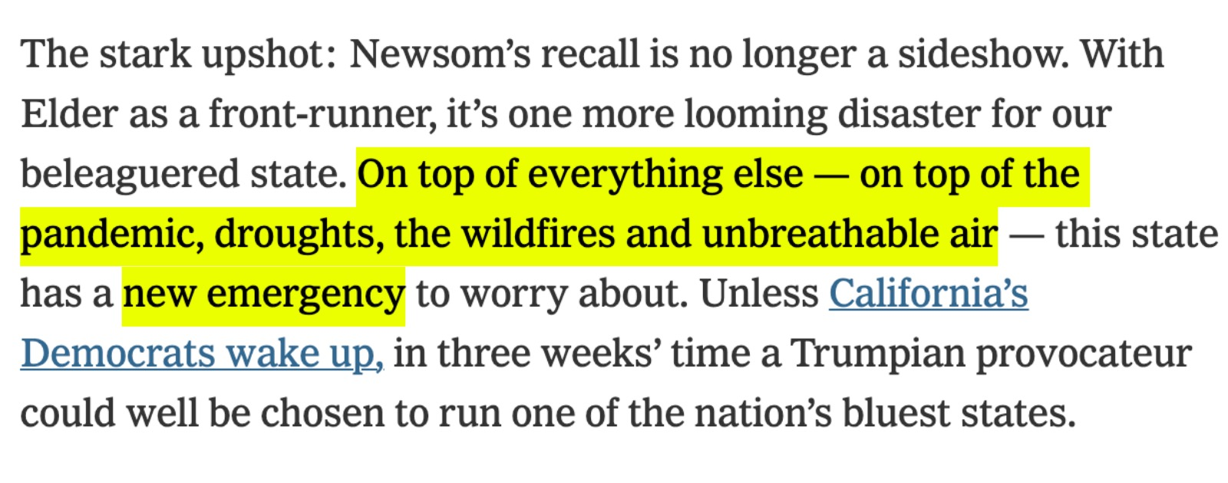
- I'm tired of cartoons like this about California being true. Let's get rid of Gavin Newsom and elect Larry Elder.
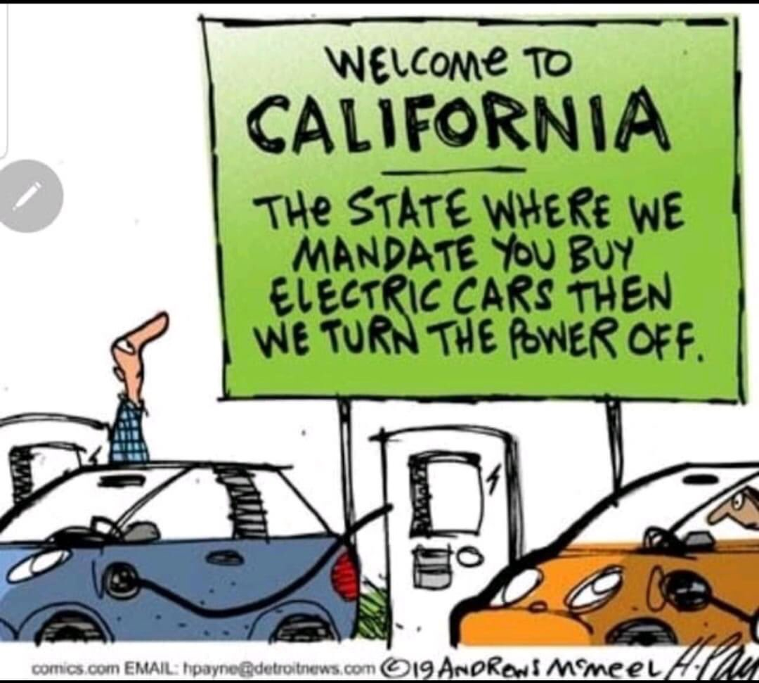

- In California, solar and wind are wrecking our electricity while our nuclear plant in Diablo Canyon is one of our main saviors.
But our energy policy is so bad that we're planning on shutting down our nuclear plant and replacing it with a bunch of wind turbines.
Recall Newsom.
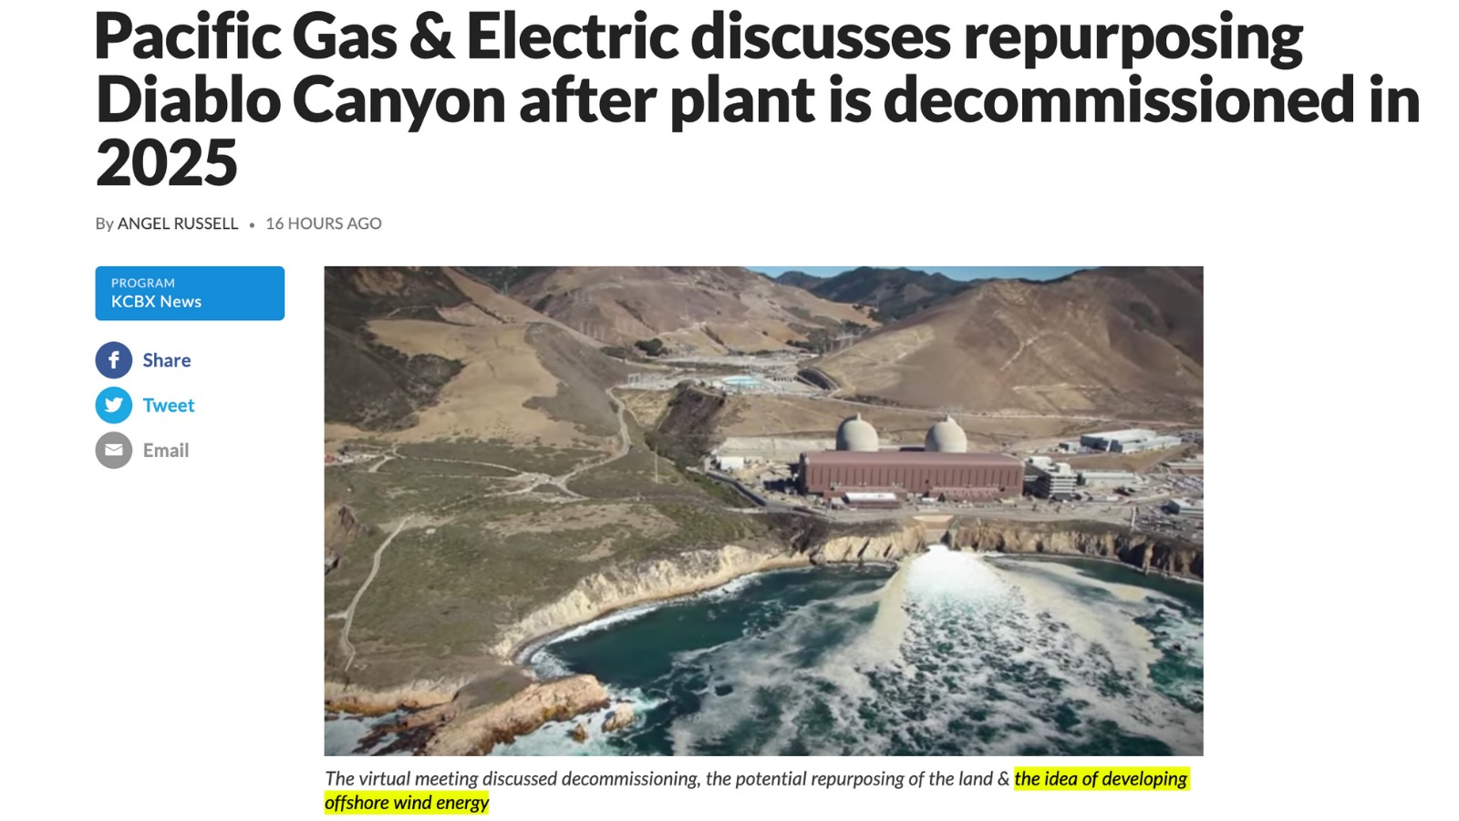

Some good research by shared by Bjorn Lomborg and Roger Pielke, Jr.
Here's some some good information by Roger Pielke Jr. on declining vulnerability.
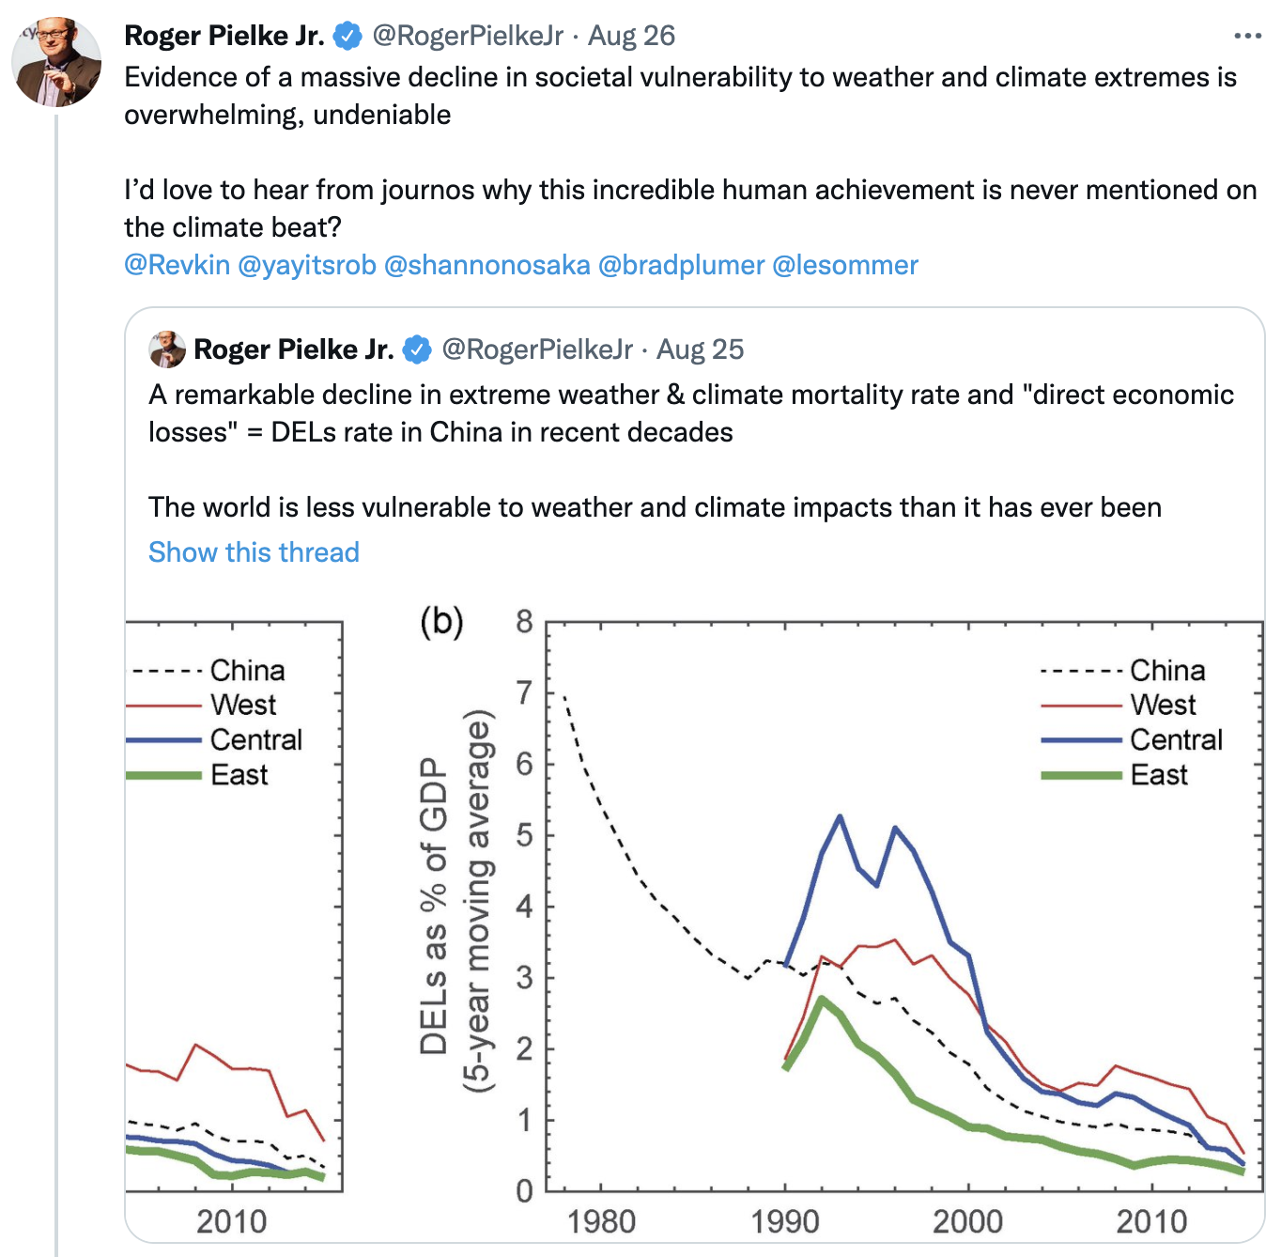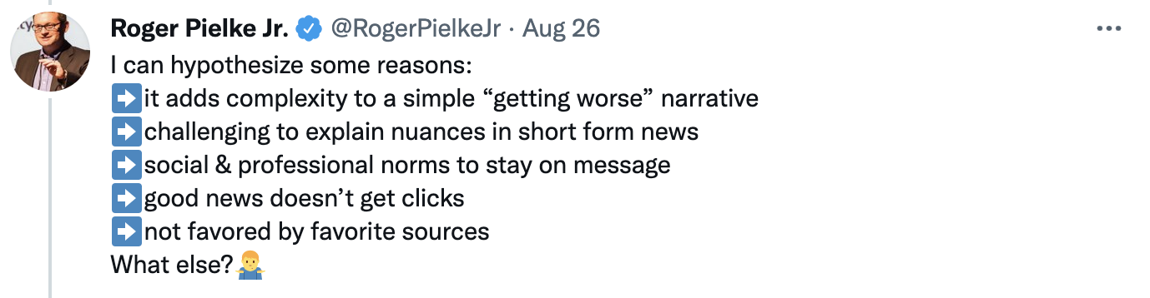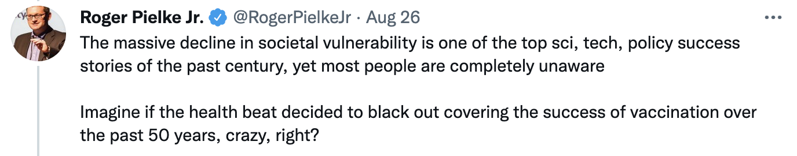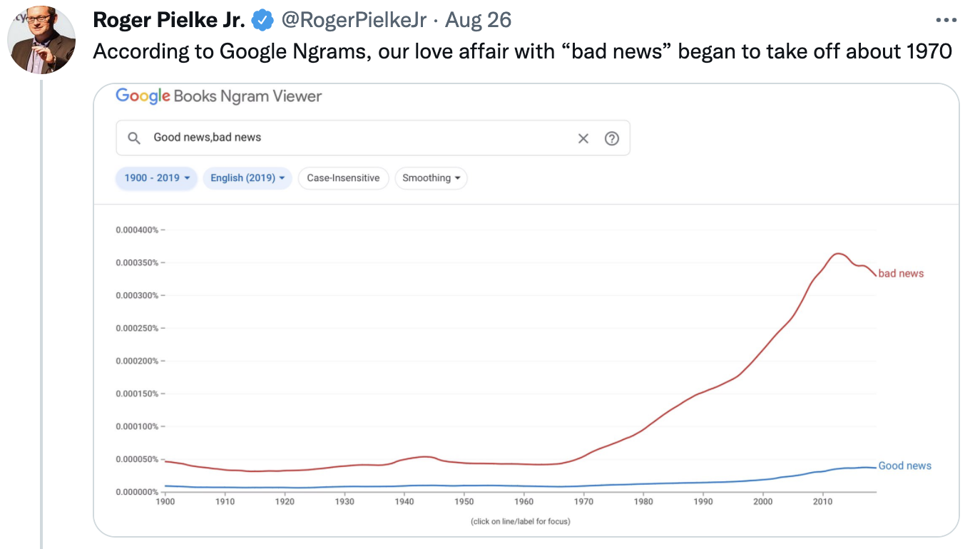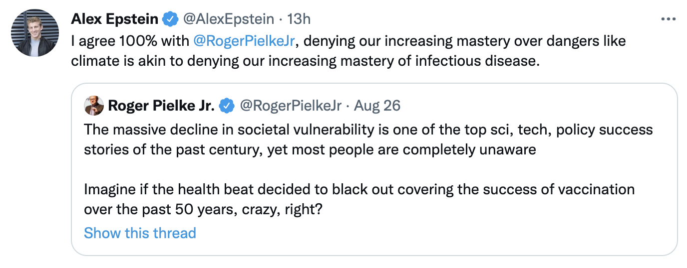
Here's some good debunking by Bjorn Lomborg of media coverage of heat deaths.
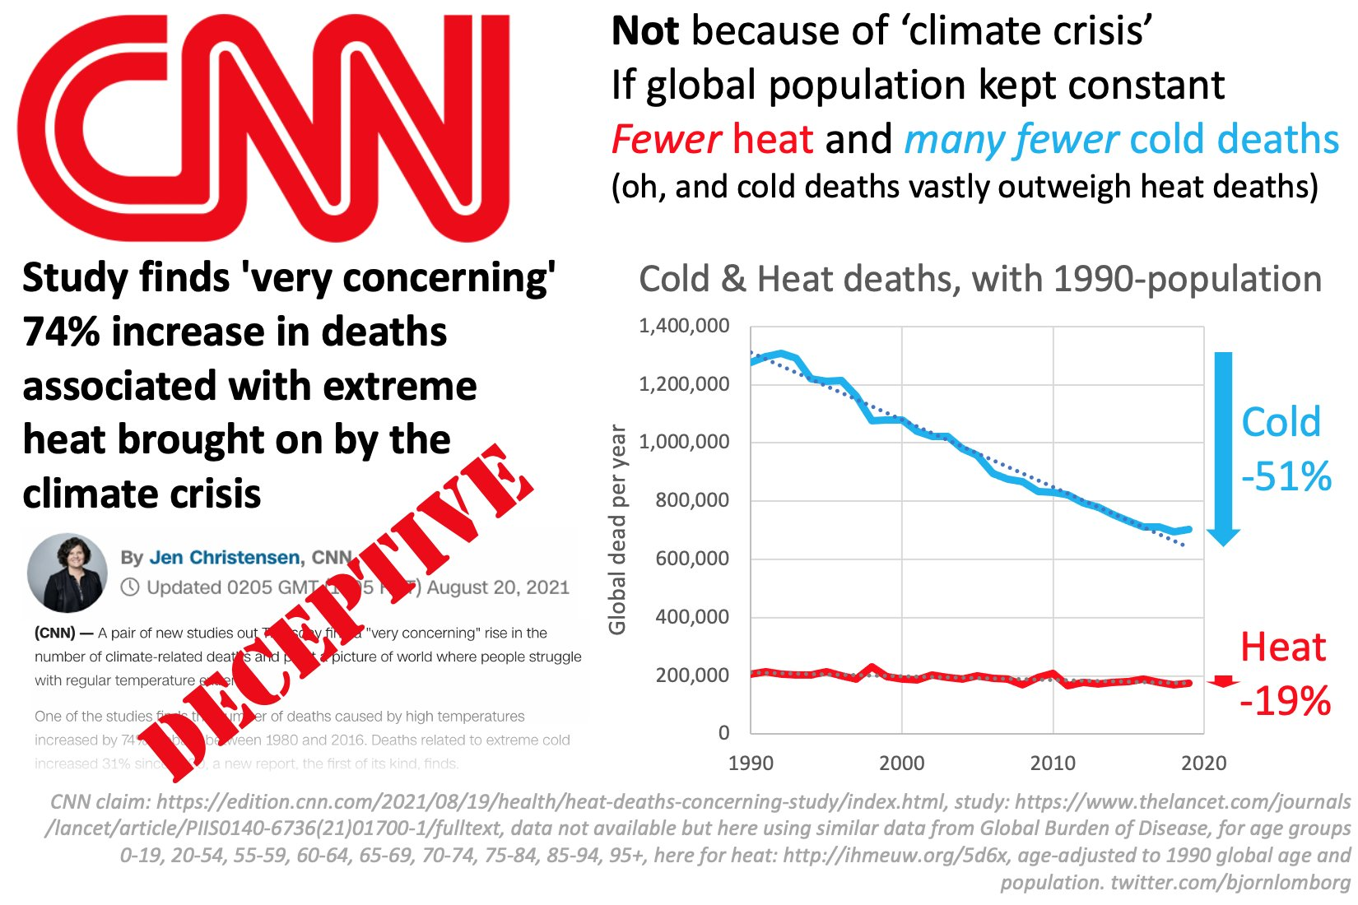
Here’s Bjorn Lomborg’s whole thread.

U.S. Energy Information Administration - Electric Power Annual
Clean Air Task Force - Clean Electricity Payment Program
Public generation of electricity was over 488 terawatt-hours in Germany for 2020, solar and wind combined generated over 37%. In 2002 they generated just over 3%. Fraunhofer ISE energy-charts.de German household electricity prices have more than doubled to over 0.3€ per kWh ($0.35 per kWh depending on currency exchange rate) since 2000 when the modern renewable energy law started to massively incentivize solar and wind capacity on the German grid. BDEW Strompreisanalyse Jan 2021 p. 7
California, where solar & wind generation increased from 1.5% in 2001 to 24% in 2020 (and imports increased from 24% to 31%), residential electricity prices escalated almost 30% faster than in the US as a whole. That doesn’t even include the costs of the 2020 blackout debacle, caused by the system operators inability to secure enough electricity imports when solar and wind failed. U.S. energy Information Administration - Electricity data browser California Energy Commission - 2020 Total System Electric Generation
Alex Epstein - Talking Points on the Texas Electricity Crisis
U.S. Energy Information Administration - Hourly Electric Grid Monitor
Politico - Schumer: Infrastructure bills would curb emissions 45 percent
China’s primary energy consumption from coal, oil, and natural gas was over 85% of the total in 2019. BP Statistical Review of World Energy 2020
David Wojick - CHINA LOVES COAL FAR MORE THAN WIND As of January 2021, China is planning or constructing over 200 new coal-fired power plants with a combined capacity of over 247 GW. Global energy Monitor - Global Coal Plant TrackerAmerica’s Power - China’s Coal Fleet Continues to Grow
Energy Talking Points on Wind Production Tax Credit
WSJ - Climate Change to Be Treated as Public-Health Issue
https://www.urban.org/sites/default/files/publication/49116/2000178-How-are-Income-and-Wealth-Linked-to-Health-and-Longevity.pdf
https://scrippsco2.ucsd.edu/data/atmospheric_co2/icecore_merged_products.html https://www.emdat.be/

